**User Manual – Administrator**

**Intelligent search in product records**

Lukáš Cauner, Marián Kica, Adrián Kyška, Dávid Laurovič

30.01.2023

**Contents**

User interface overview 3

Main screen – Search tab (First search) 3

Search tab (Second search) 3

History tab (Main) 4

History tab (Detail) 5

Log in/out and password management 5

Log in 5

Log out 6

Change password 7

Search 8

Performing search 8

Saving search results 9

Exporting 10

History 11

Browse history 11

History detail 11

Deleting history 12

Exporting 13

Category management 13

Change part category 13

# User interface overview

## Main screen – Search tab (First search)

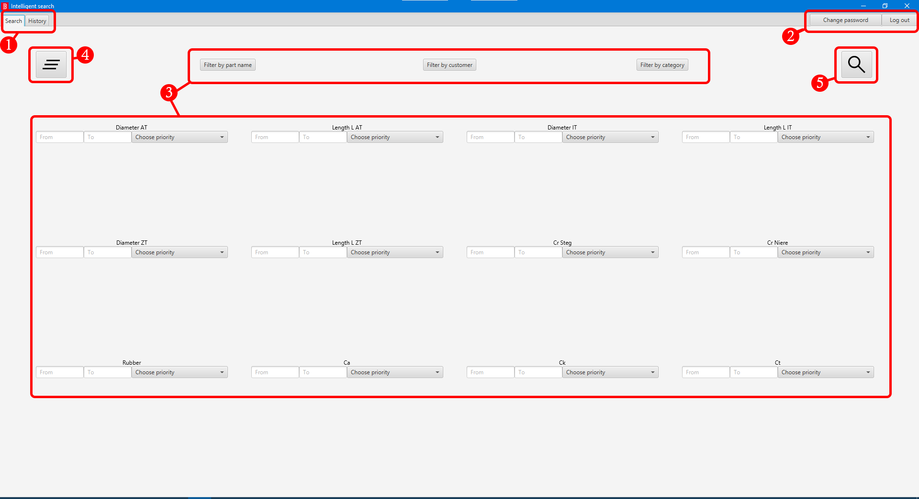

1. Application tabs
2. Change password / Log out buttons
3. Filters
4. Clear all filters button
5. Search button

## Search tab (Second search)

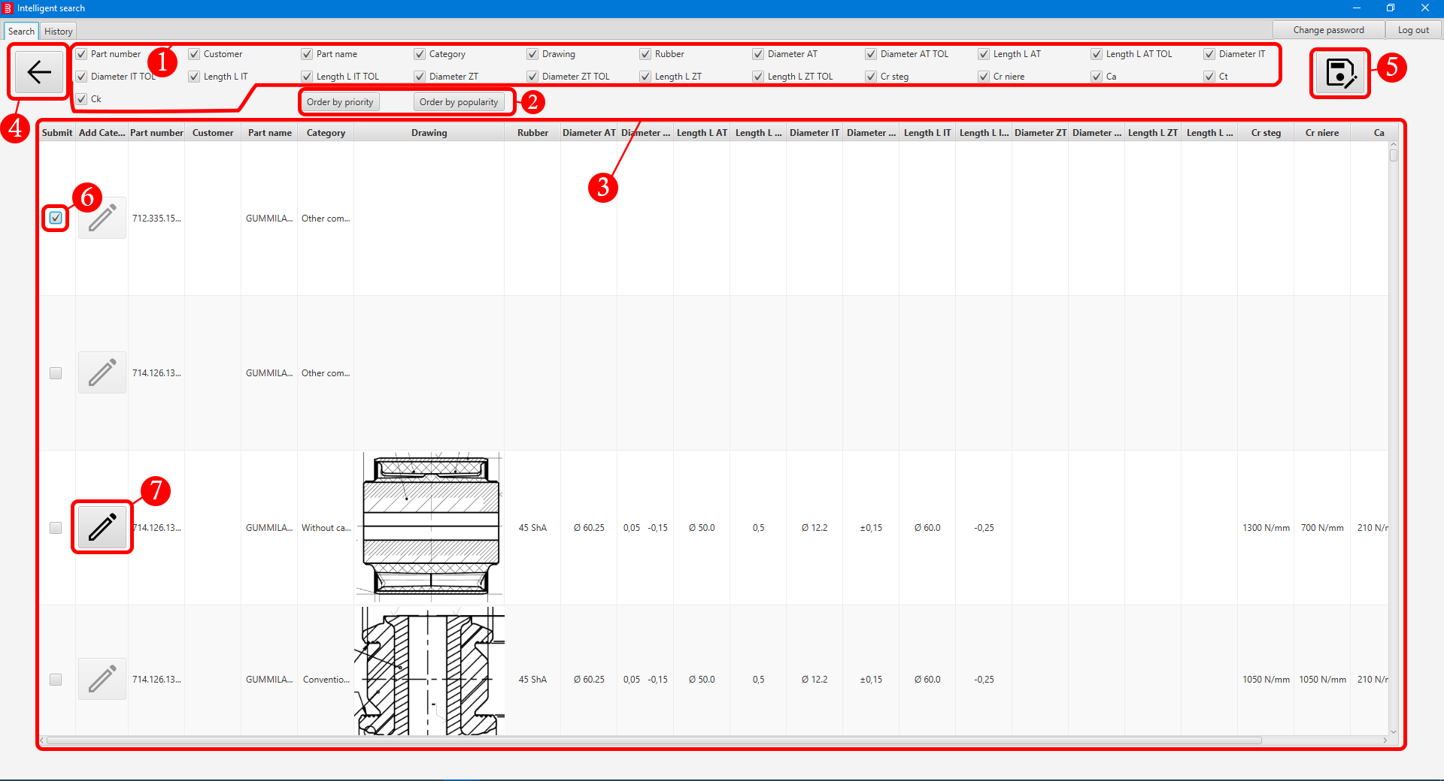

1. Activate / Hide column(s)
2. Filters
3. Search result list
4. Back button (back to First search)
5. Confirm / Save search
6. Checkbox for selecting desired search result(s)
7. Edit category button

## History tab (Main)

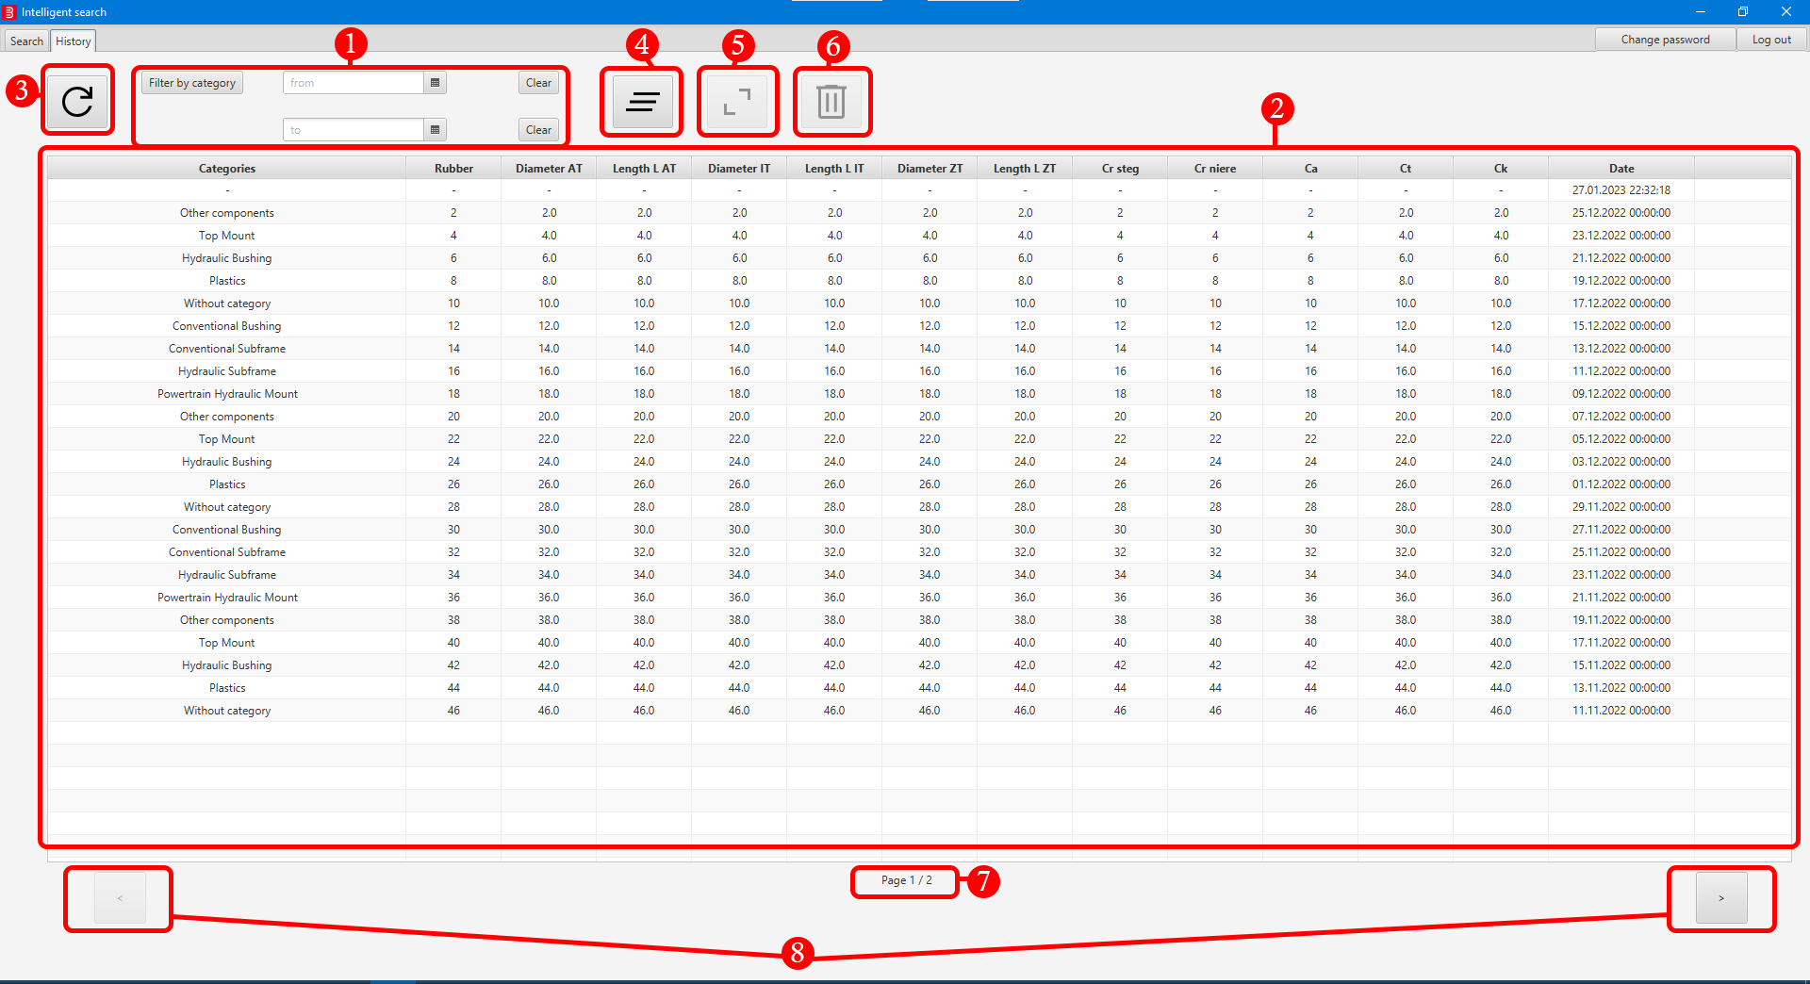

1. Filters
2. History list
3. Refresh list
4. Clear all filters button
5. Open selected row button
6. Delete selected row(s) button
7. Page information
8. Next / Previous page buttons

## History tab (Detail)

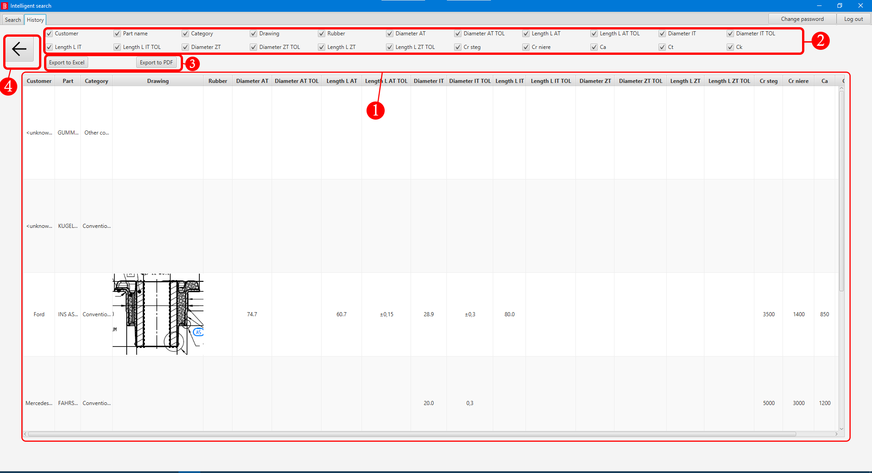

1. Part list
2. Activate / Hide column(s)
3. Export to PDF / Excel
4. Back button (back to History (Main))

# Log in/out and password management

## Log in

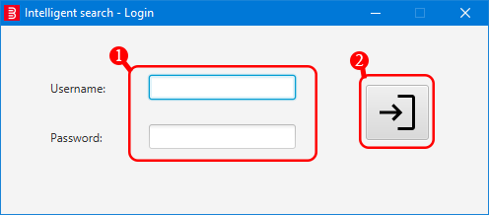

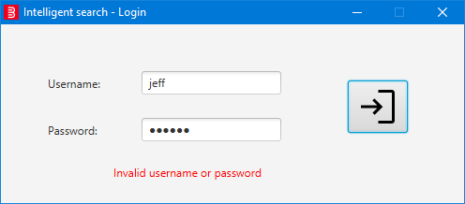

1. Type in **your username** and **password**.
2. Click on **log in icon** or press **Enter** key on your keyboard. In case of an error, a text message will be shown.

## Log out

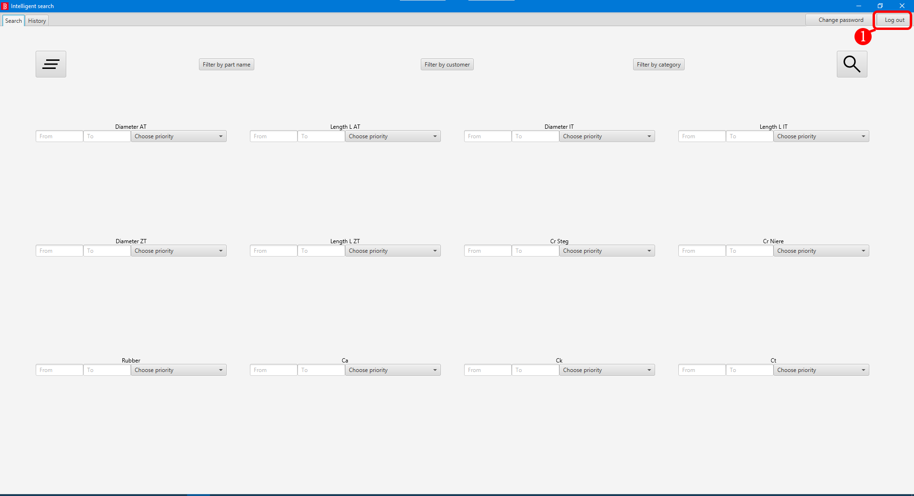

1. Click the **Log out** button located at the top right corner. Window will close and you will be greeted with log in window.

## Change password

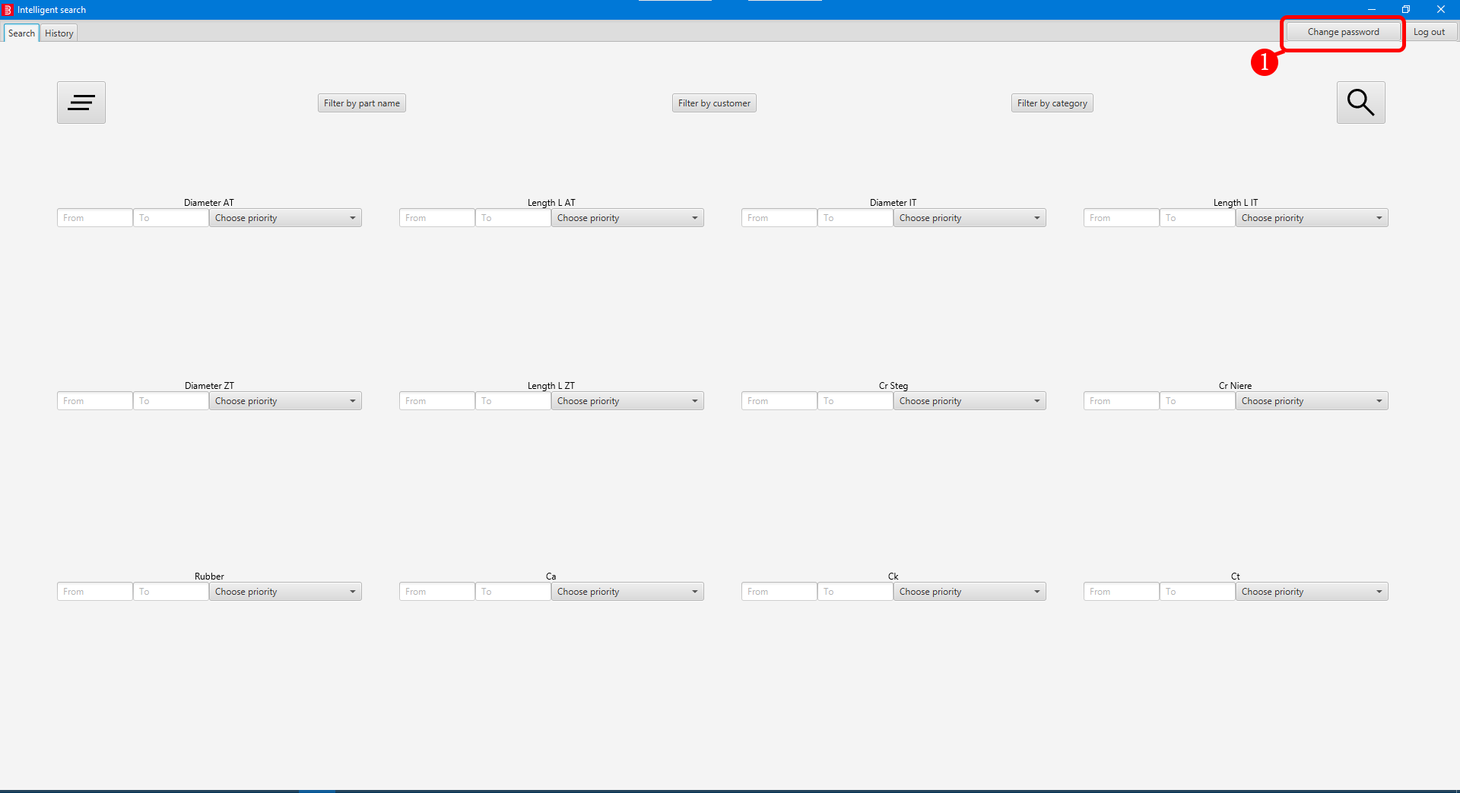

Obrázok, na ktorom je text

Automaticky generovaný popis

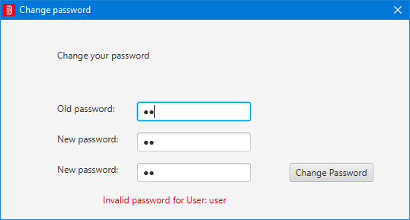

1. Click the **Change password** button located at the top right corner, new window will open.
2. Type in your **old password**.
3. Type in your **new password 2x**.
4. Click on **Change password**. In case of an error, a text message will be shown. Otherwise, the window will close and your **password will be changed**.

# Search

## Performing search

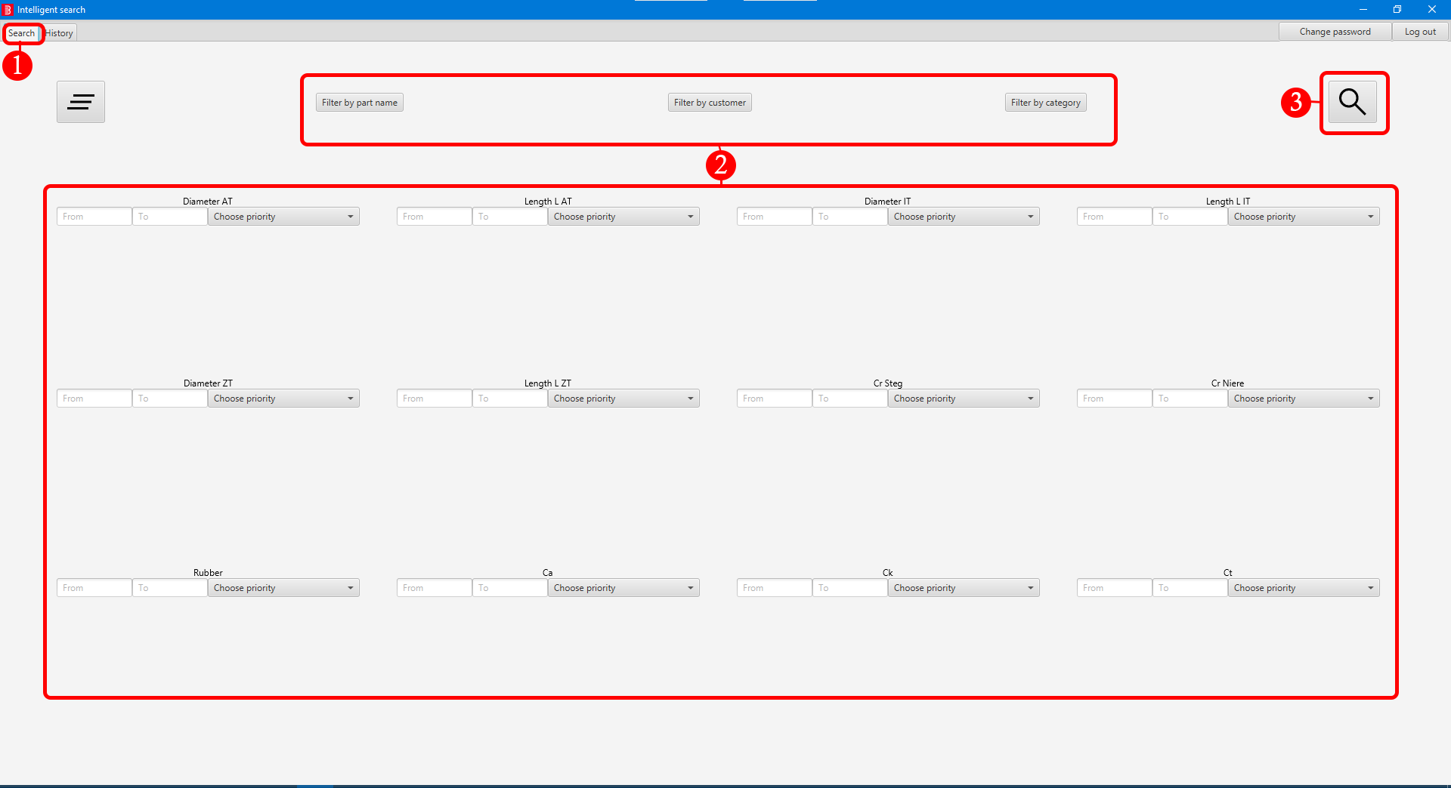

1. Click on the **Search** tab.
2. (Optional) Apply **filters**.
   1. (Optional) Click on **Filter by part name** button, new window will open, select desired part name(s) and confirm your choice. When filter is applied button background is darker, indicating that filter is active.
   2. (Optional) Click on **Filter by customer** button, new window will open, select desired customer(s) and confirm your choice. When filter is applied button background is darker, indicating that filter is active.
   3. (Optional) Click on **Filter by category**, new window will open, select desired category(es) and confirm your choice. When filter is applied button background is darker, indicating that filter is active.
   4. (Optional) Type in values in text fields of any desired parameter(s).
   5. (Optional) Assign priority for any desired parameter(s).
3. Click on **Search** button. Results of your search will be shown on your screen.

## Saving search results

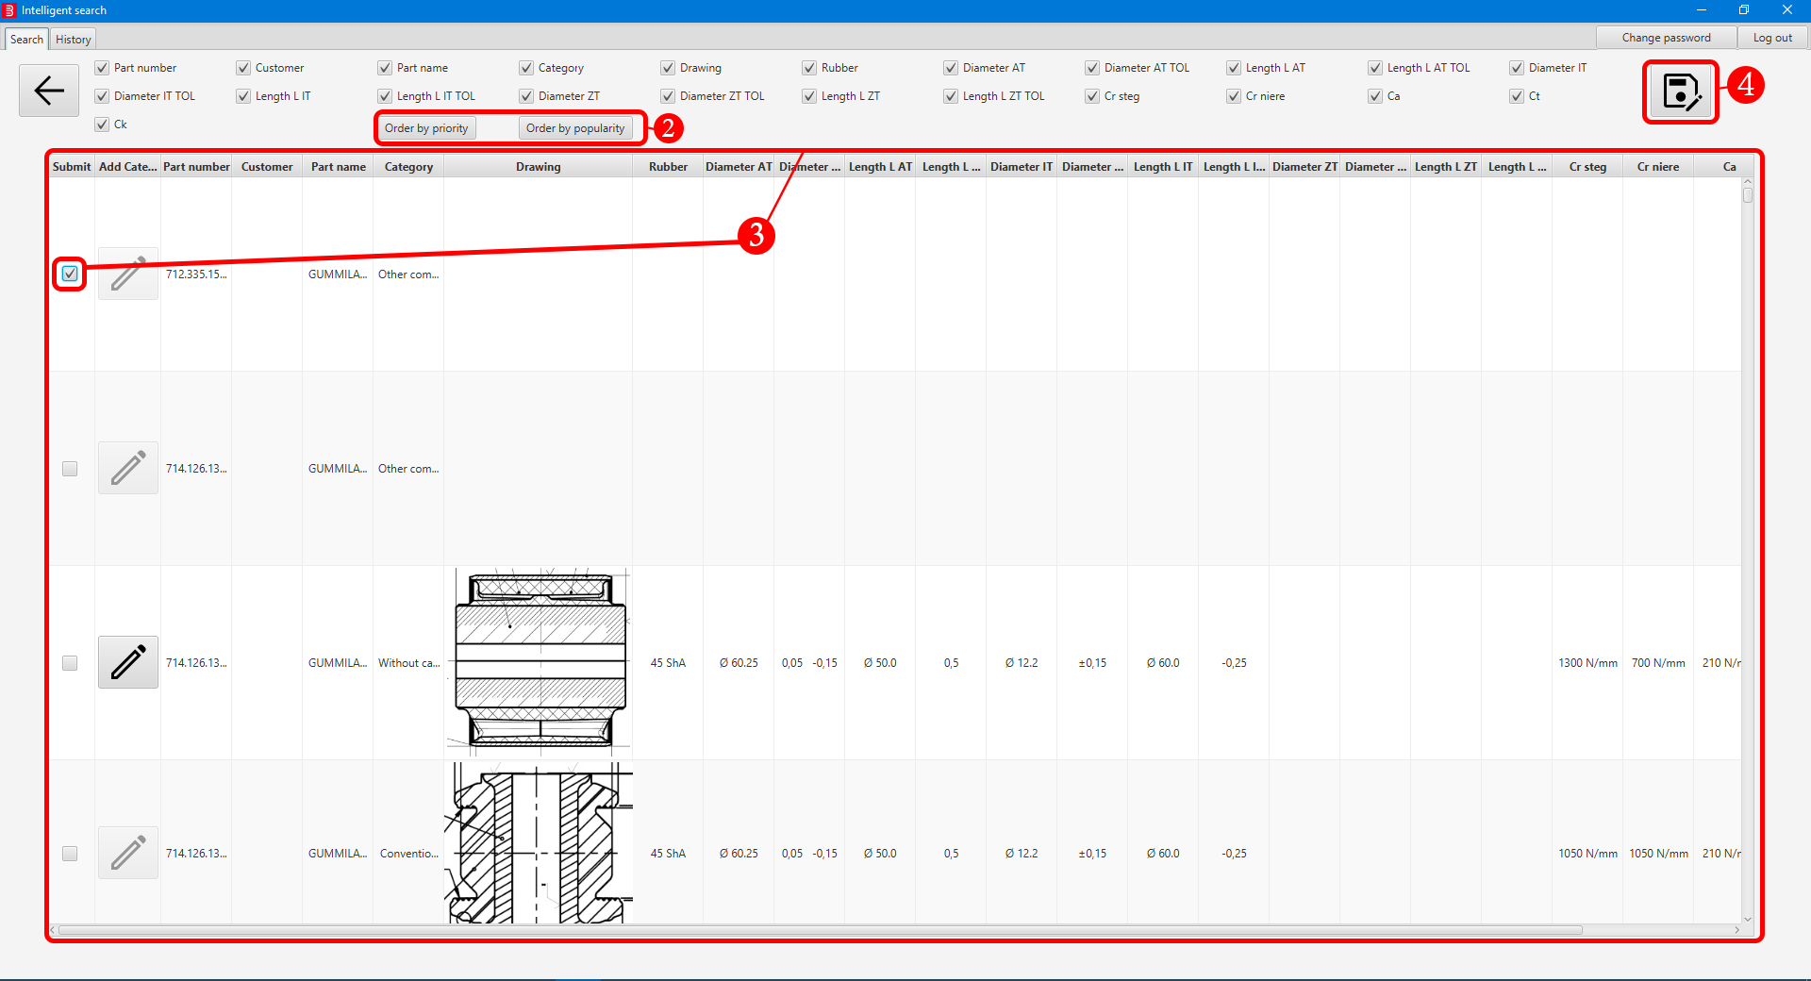

Obrázok, na ktorom je text

Automaticky generovaný popis

1. **Perform search**. Check **Performing search** chapter for more details.
2. (Optional) Result **ordering**. Following options are **mutually exclusive**.
   1. (Optional) Order your results by **priority**.
   2. (Optional) Order your results by **popularity**.
3. Navigate the result(s) and **select** **desired** **parts** by clicking on the **checkbox(es).**
4. Click on the **save** button, new window will open.
5. (Optional) Click on **Export to PDF** or **Export to Excel** to **export** your results. You will be prompted to **select** **location** where it will be **exported**.
6. Click on **Save to history** button to **save** **your search** and **finish** **the search**. After that you will be returned to main screen - First search.

## Exporting

1. Exporting is associated with **searching**. Check **Performing search** **and Saving search results** chapters for more details.

**Note: For export to work, path to save file can’t contain diacritics, i.e. ´ or ˇ**

# History

## Browse history

Obrázok, na ktorom je stôl

Automaticky generovaný popis

1. Click on the **History** tab. (History should be refreshed automatically on entering this tab, if no use manual refresh, see History tab (Main) section)
2. (Optional) History **filtering**.
   1. (Optional) Click on **Filter by category** button, new window will open, select desired category(es) and confirm your choice. When filter is applied button background is darker, indicating that filter is active.
3. View results.

## History detail

Obrázok, na ktorom je stôl

Automaticky generovaný popis

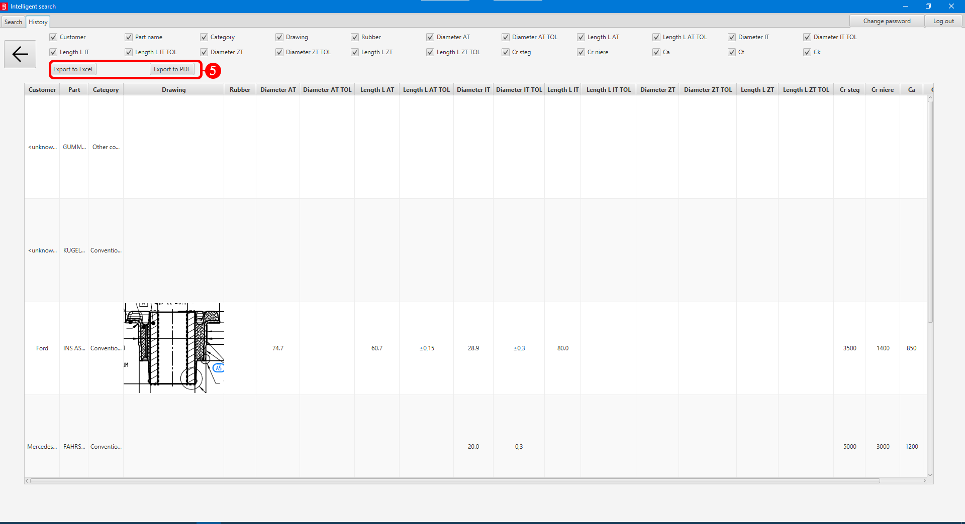

1. **Browse history**. Check **Browse history** chapter for more details.
2. Click on desired row. Selected row will be **highlighted**.
3. Click on open row button (**Button is only enabled when only one row is selected**).

Or

1. Double click on the desired row.
2. History detail will be shown on your screen.
3. (Optional) Click on **Export to PDF** or **Export to Excel** to export.

## Deleting history

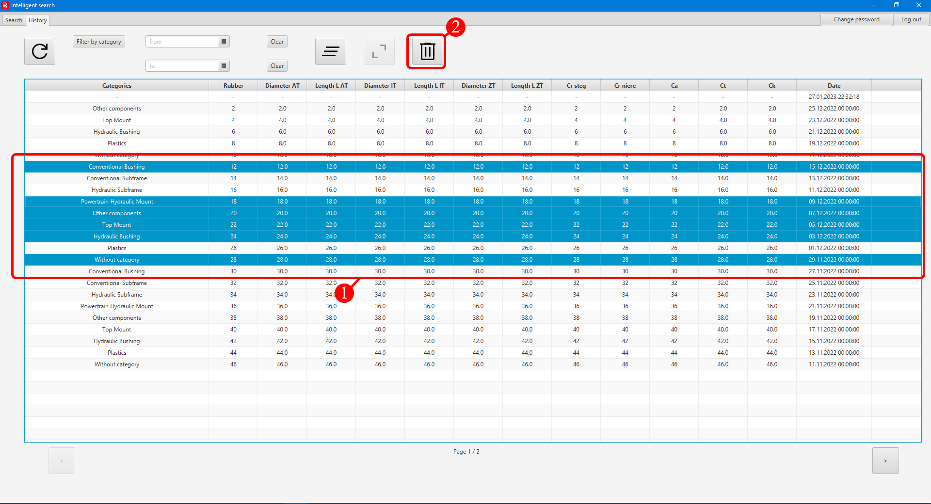

1. **Browse history**. Check **Browse history** chapter for more details.
2. Row **selection**.
   1. To select only one row, left click on the row. Selected row will be highlighted.
   2. To select multiple rows from start to end, left click on any row to select the start, then while holding the left Shift key left click on the end row. Selected row(s) will be highlighted.
   3. To select multiple rows, while holding the left Shift key left click on any other row you wish to add to your selection. Selected row(s) will be highlighted.
3. Click on the **Bin icon**, new window will open.
4. Click the **confirm** button to **confirm** **the** **deletion**. Selected row(s) will be **permanently deleted**.

## Exporting

1. Exporting is associated with **History detail**. Check **History detail** chapter for more details.

**Note: For export to work, path to save file can’t contain diacritics, i.e. ´ or ˇ**

# Category management

## Change part category

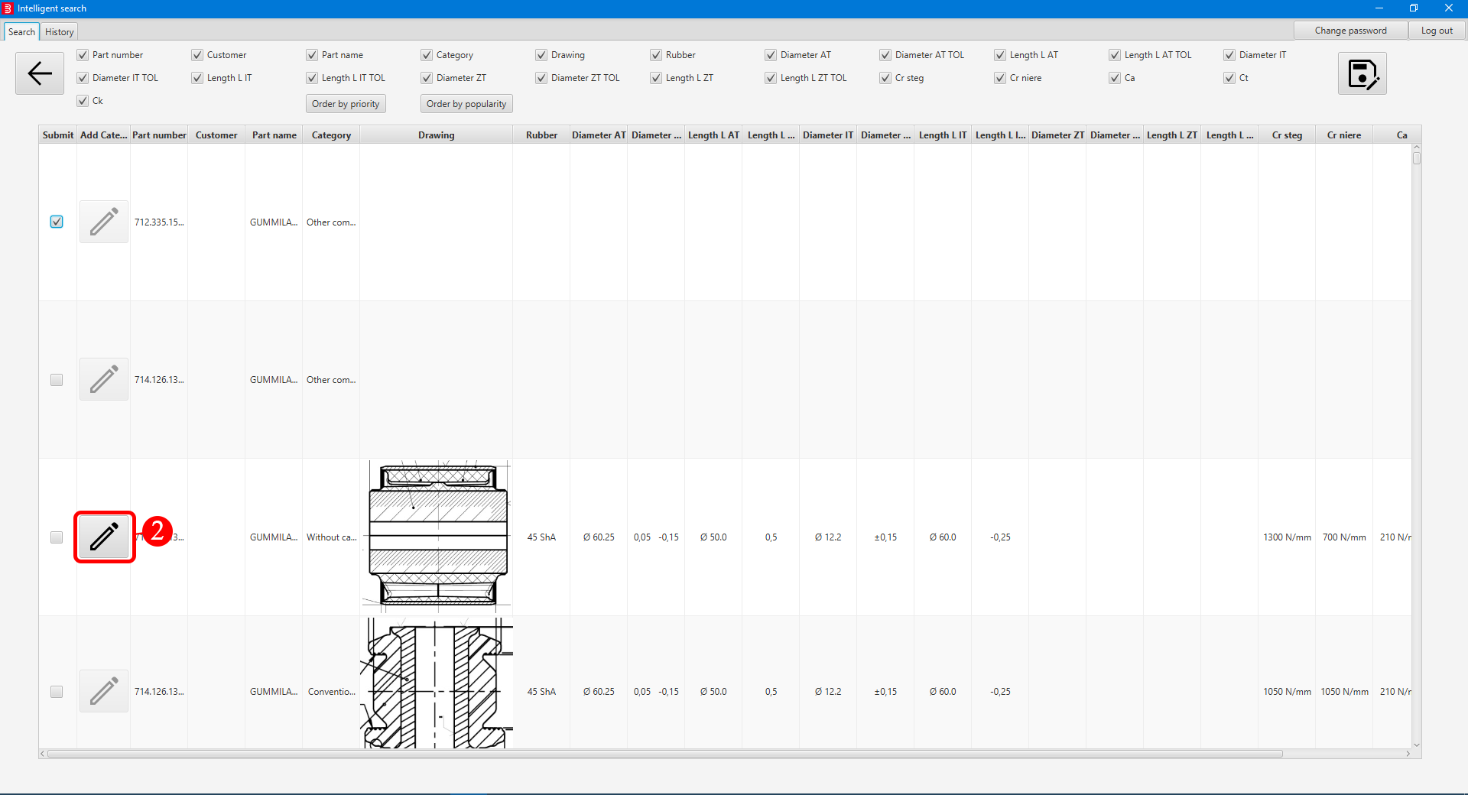

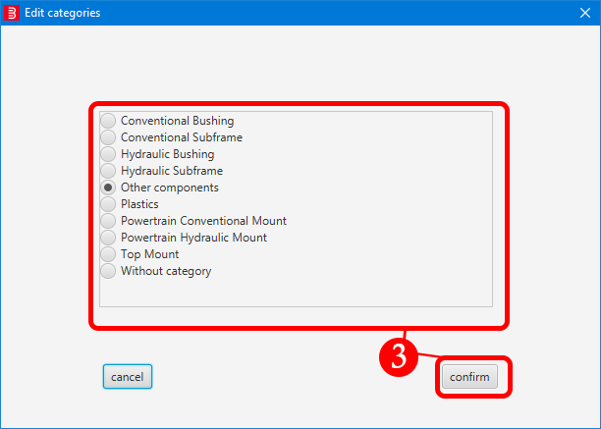

1. **Perform search**. Check **Performing search** chapter for more details.
2. Click on the **edit icon**, new window will open.
3. Select **new category** from the list and **confirm** your choice. The window will close and part category will be updated.

**Note: You can only change category for parts that are without category i.e. Their category is** “**Without category”**.

Contents

User interface overview 3

Main screen – Search tab (First search) 3

Search tab (Second search) 3

History tab (Main) 4

History tab (Detail) 5

User management tab 5

Category management tab 6

Log in/out and password management 6

Log in 6

Log out 7

Change password 8

Search 9

Performing search 9

Saving search results 10

Exporting 11

History 12

Browse history 12

History detail 13

Deleting history 14

Exporting 14

User management 15

Add user 15

Suspend/Enable user 16

Category management 16

Add category 16

Rename category 17

Delete category 18

Change popularity of part 19

Change part category 19

Import 20

Import 20

Handling errors 21

# User interface overview

## Main screen – Search tab (First search)

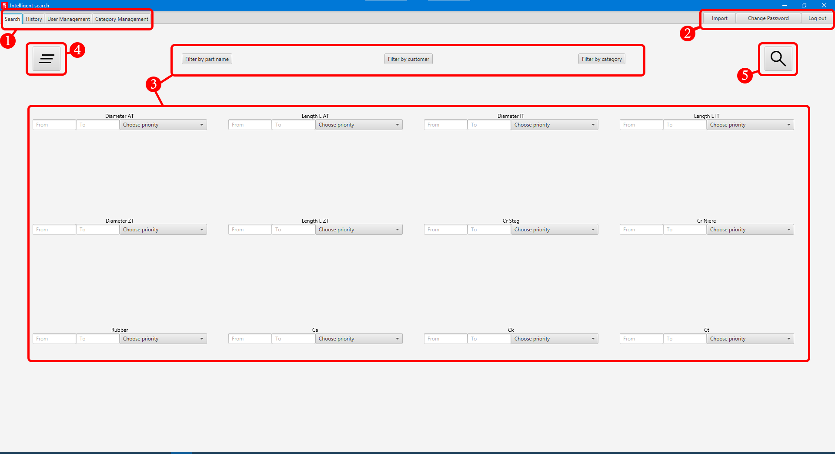

1. Application tabs
2. Import / Change password / Log out buttons
3. Filters
4. Clear all filters button
5. Search button

## Search tab (Second search)

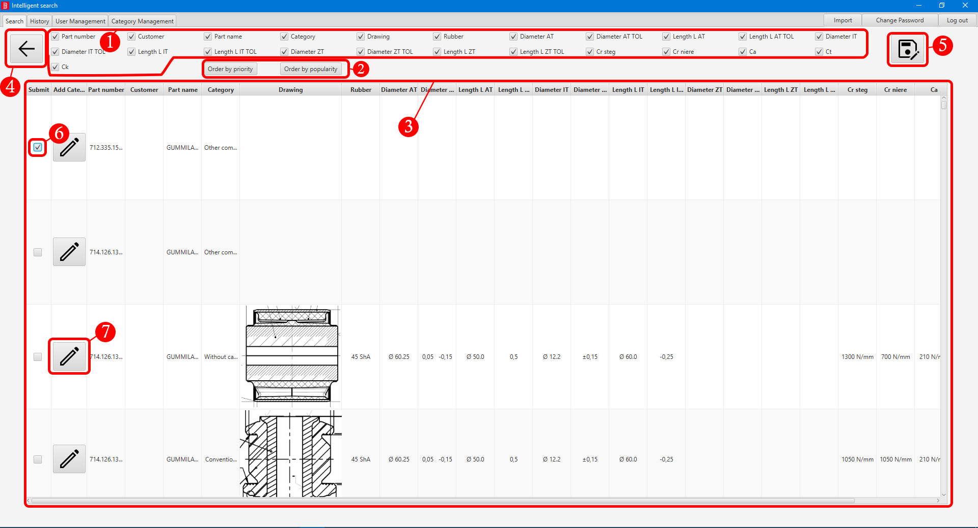

1. Activate / Hide column(s)
2. Filters
3. Search result list
4. Back button (back to First search)
5. Confirm / Save search
6. Checkbox for selecting desired search result(s)
7. Edit category button

## History tab (Main)

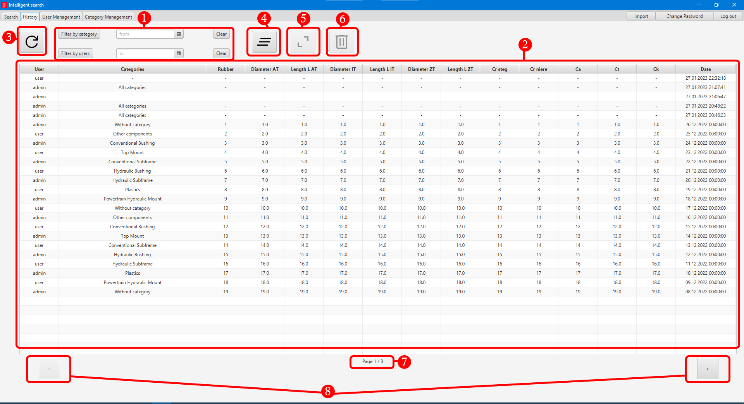

1. Filters
2. History list
3. Refresh list
4. Clear all filters button
5. Open selected row button
6. Delete selected row(s) button
7. Page information
8. Next / Previous page buttons

## History tab (Detail)

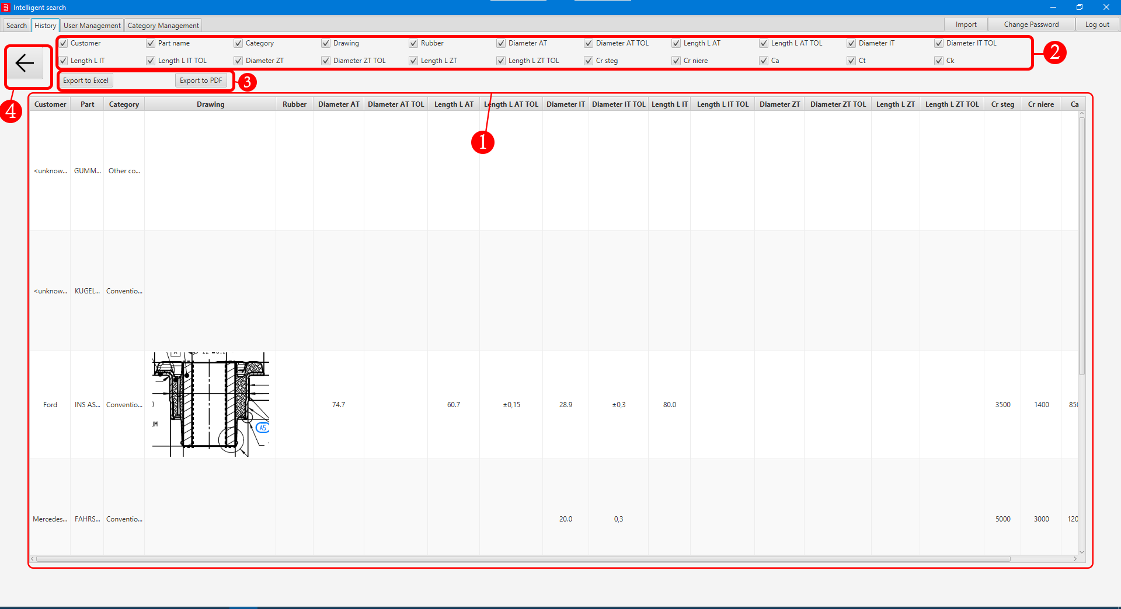

1. Part list
2. Activate / Hide column(s)
3. Export to PDF / Excel
4. Back button (back to History (Main))

## User management tab

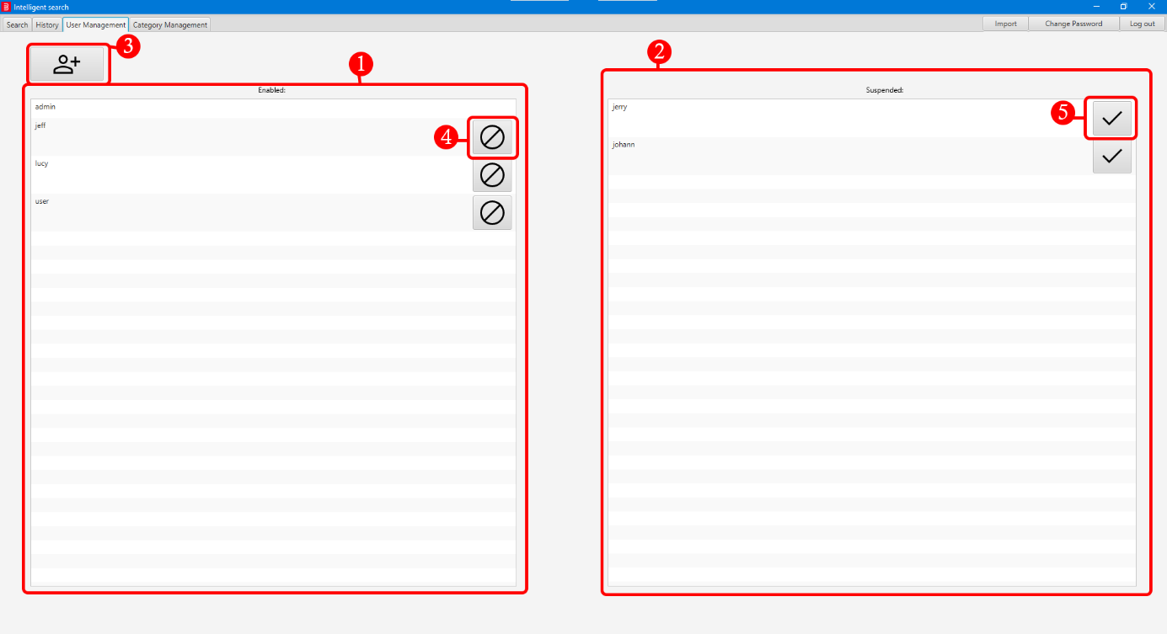

1. Enabled accounts list
2. Suspended accounts list
3. Add new account button
4. Suspend account button
5. Enable account button

## Category management tab

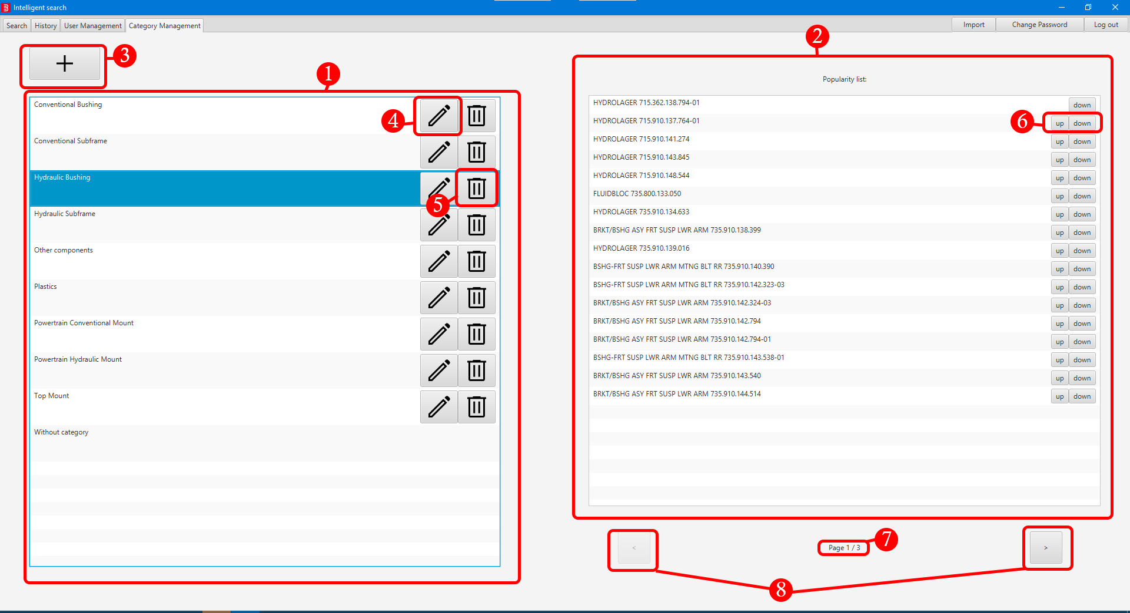

1. Category list
2. Popularity list for selected category
3. Add new category button
4. Rename category button
5. Delete category button
6. Up / Down buttons for popularity adjustments
7. Page information
8. Next / Previous page buttons

# Log in/out and password management

## Log in





1. Type in **your username** and **password**.
2. Click on **log in icon** or press **Enter** key on your keyboard. In case of an error, a text message will be shown.

## Log out

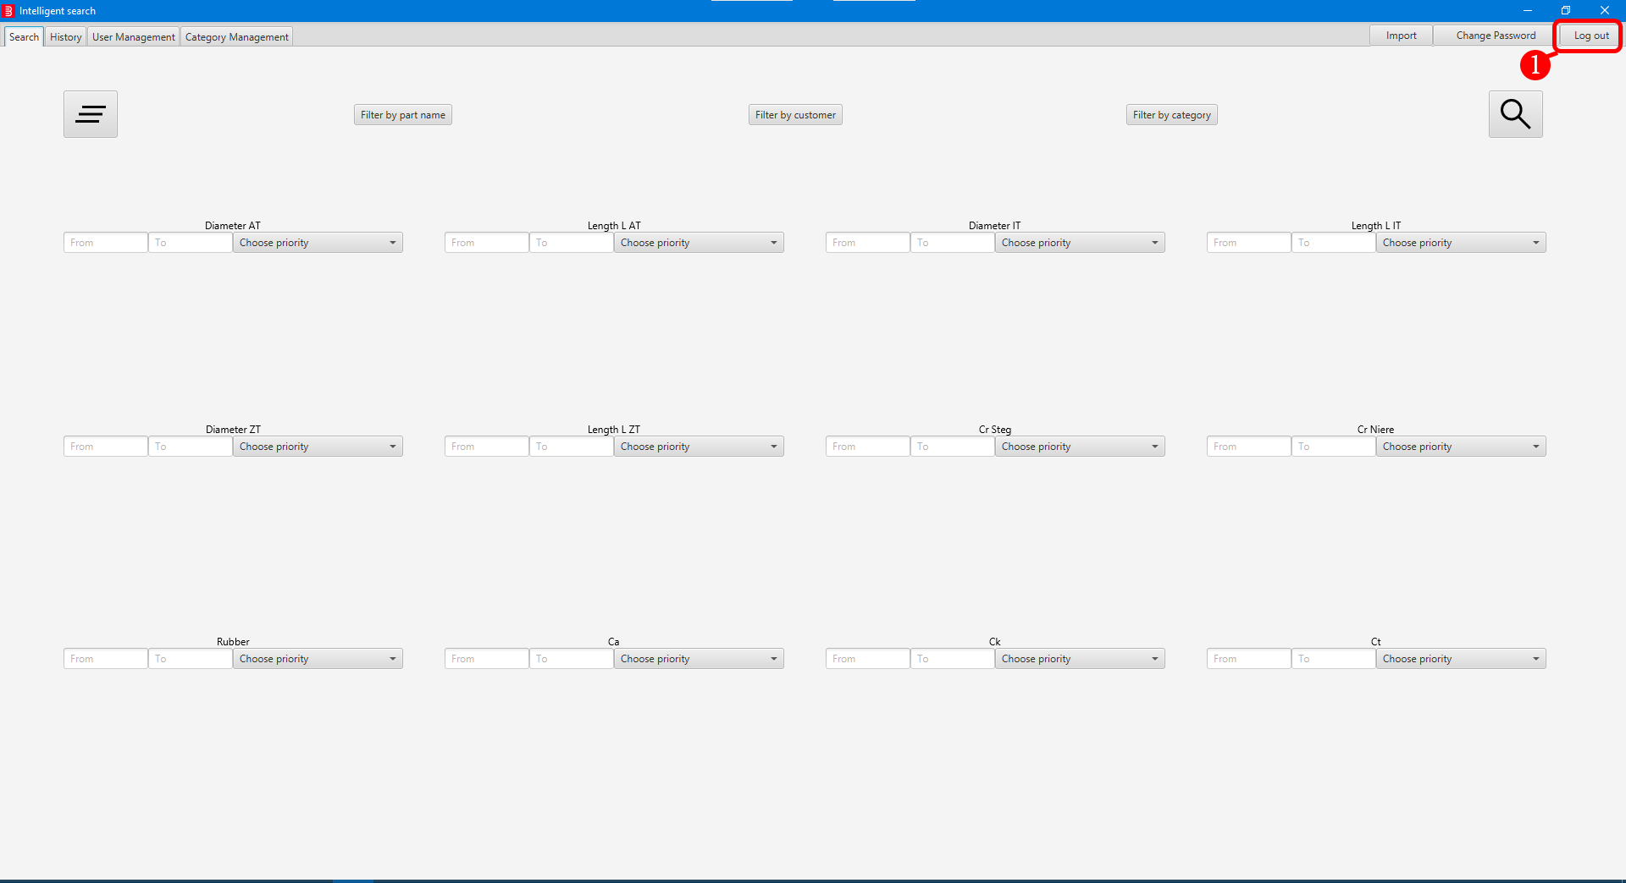

1. Click the **Log out** button located at the top right corner. Window will close and you will be greeted with log in window.

## Change password

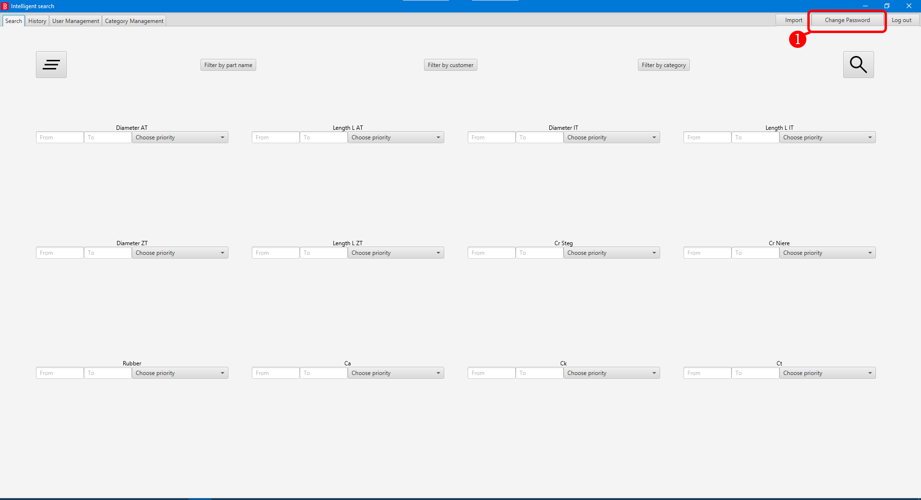

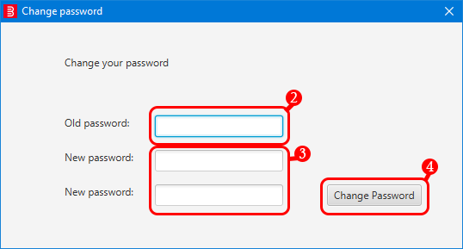



1. Click the **Change password** button located at the top right corner, new window will open.
2. Type in your **old password**.
3. Type in your **new password 2x**.
4. Click on **Change password**. In case of an error, a text message will be shown. Otherwise, the window will close and your **password will be changed**.

# Search

## Performing search

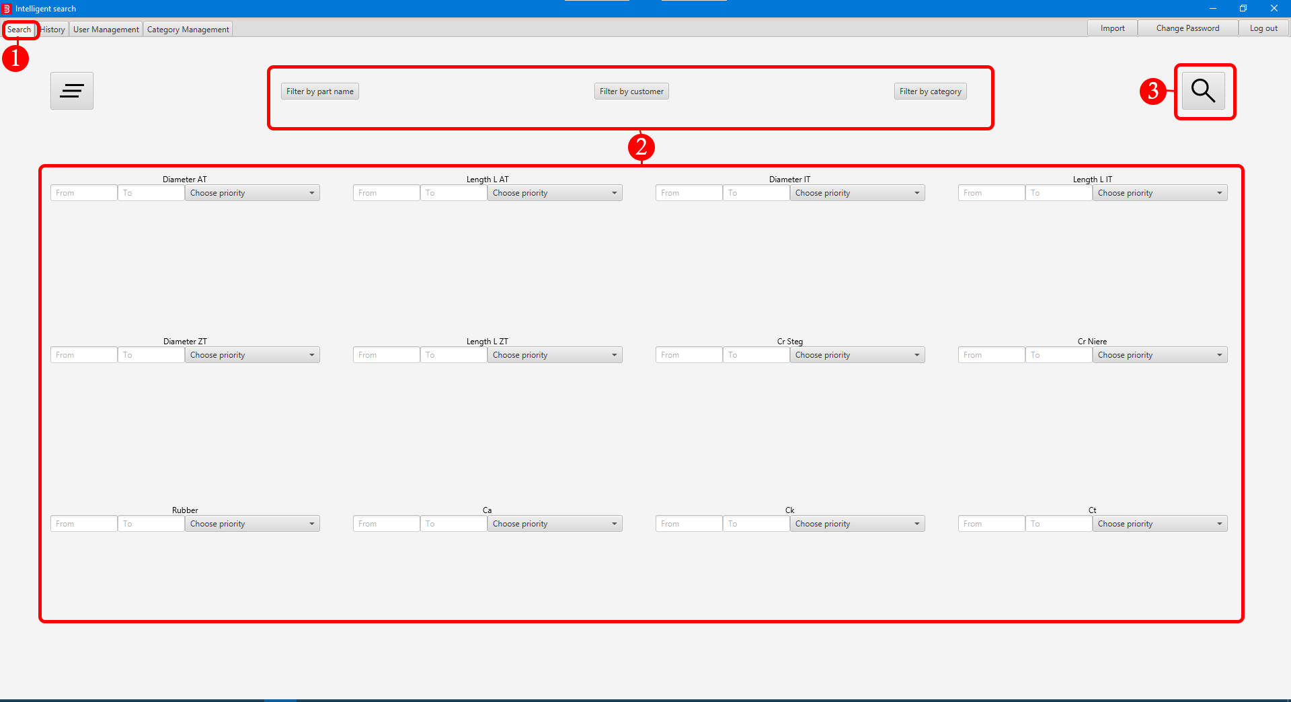

1. Click on the **Search** tab.
2. (Optional) Apply **filters**.
   1. (Optional) Click on **Filter by part name** button, new window will open, select desired part name(s) and confirm your choice. When filter is applied button background is darker, indicating that filter is active.
   2. (Optional) Click on **Filter by customer** button, new window will open, select desired customer(s) and confirm your choice. When filter is applied button background is darker, indicating that filter is active.
   3. (Optional) Click on **Filter by category**, new window will open, select desired category(es) and confirm your choice. When filter is applied button background is darker, indicating that filter is active.
   4. (Optional) Type in values in text fields of any desired parameter(s).
   5. (Optional) Assign priority for any desired parameter(s).
3. Click on **Search** button. Results of your search will be shown on your screen.

## Saving search results

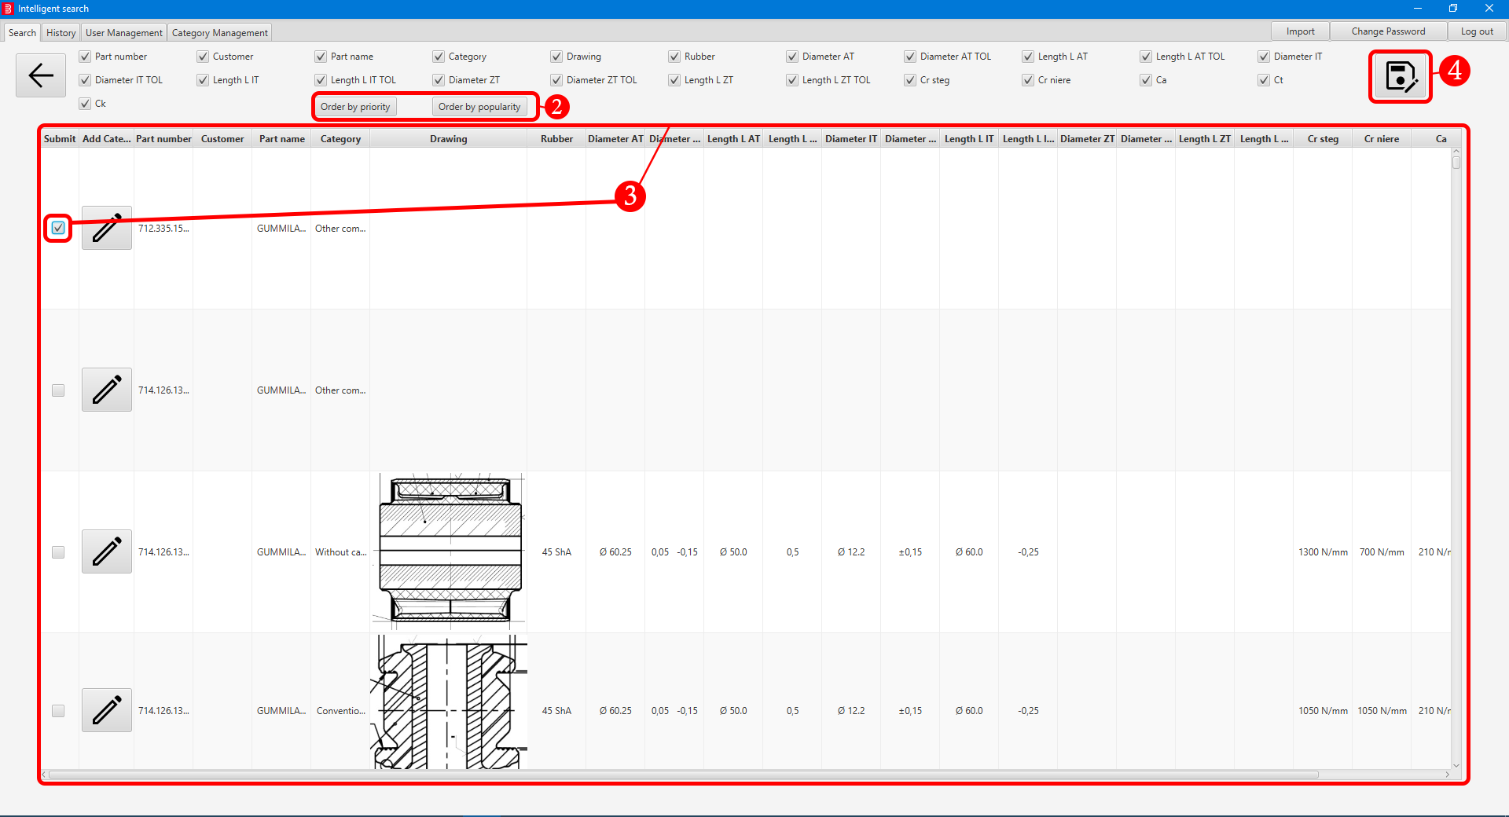

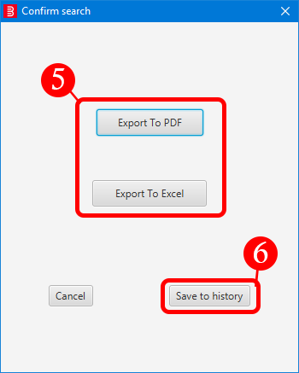

1. **Perform search**. Check **Performing search** chapter for more details.
2. (Optional) Result **ordering**. Following options are **mutually exclusive**.
   1. (Optional) Order your results by **priority**.
   2. (Optional) Order your results by **popularity**.
3. Navigate the result(s) and **select** **desired** **parts** by clicking on the **checkbox(es).**
4. Click on the **save** button, new window will open.
5. (Optional) Click on **Export to PDF** or **Export to Excel** to **export** your results. You will be prompted to **select** **location** where it will be **exported**.
6. Click on **Save to history** button to **save** **your search** and **finish** **the search**. After that you will be returned to main screen - First search.

## Exporting

1. Exporting is associated with **searching**. Check **Performing search** **and Saving search results** chapters for more details.

# History

## Browse history

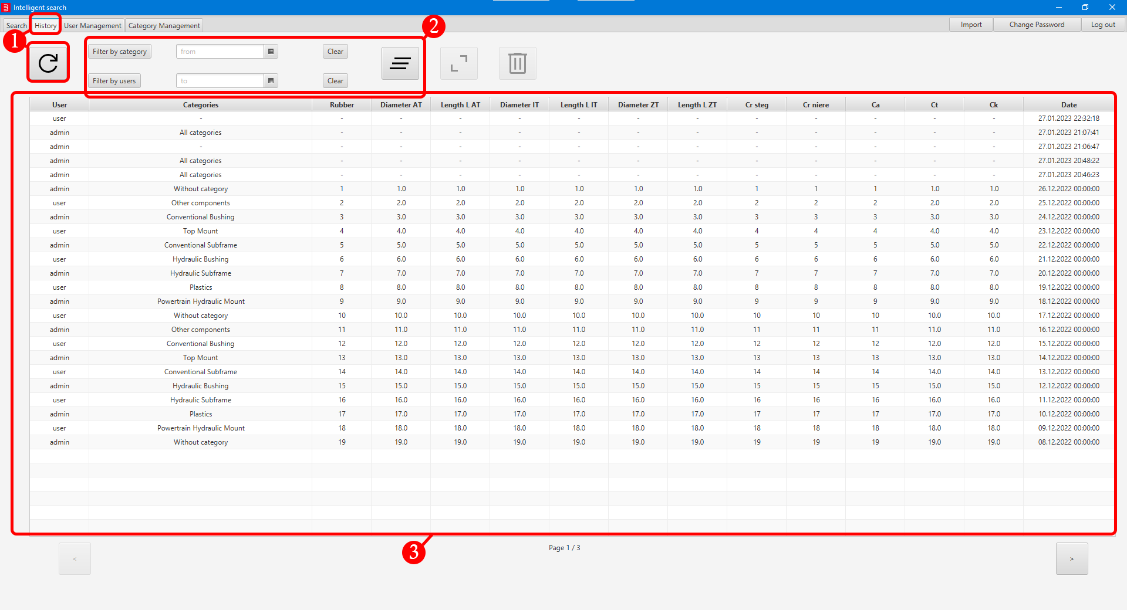

1. Click on the **History** tab. (History should be refreshed automatically on entering this tab, if no use manual refresh, see History tab (Main) section)
2. (Optional) History **filtering**.
   1. (Optional) Click on **Filter by category** button, new window will open, select desired category(es) and confirm your choice. When filter is applied button background is darker, indicating that filter is active.
   2. (Optional) Click **Filter by users** button, new window will open, select desired user(s) and confirm your choice. When filter is applied button background is darker, indicating that filter is active.
3. View results.

## History detail

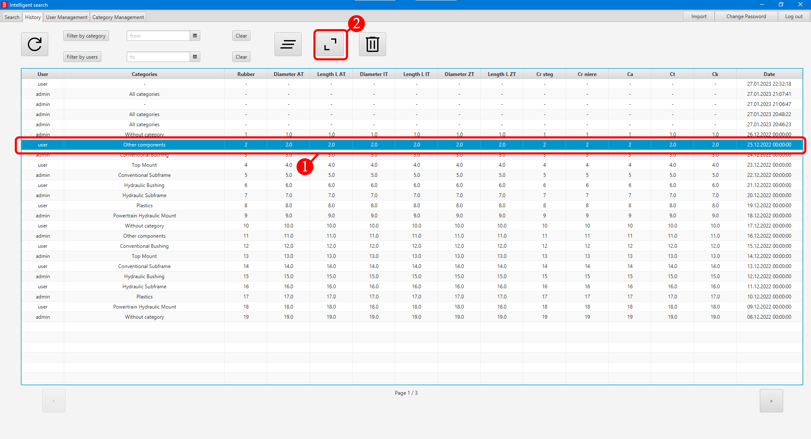

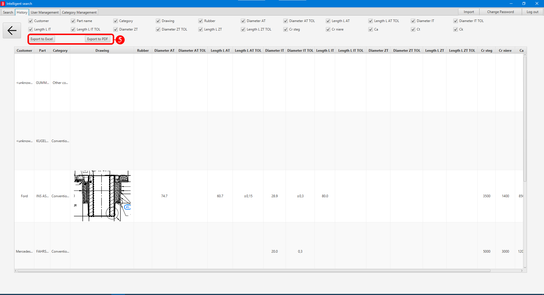

1. **Browse history**. Check **Browse history** chapter for more details.
2. Click on desired row. Selected row will be **highlighted**.
3. Click on open row button (**Button is only enabled when only one row is selected**).

Or

1. Double click on the desired row.
2. History detail will be shown on your screen.
3. (Optional) Click on **Export to PDF** or **Export to Excel** to export.

## Deleting history

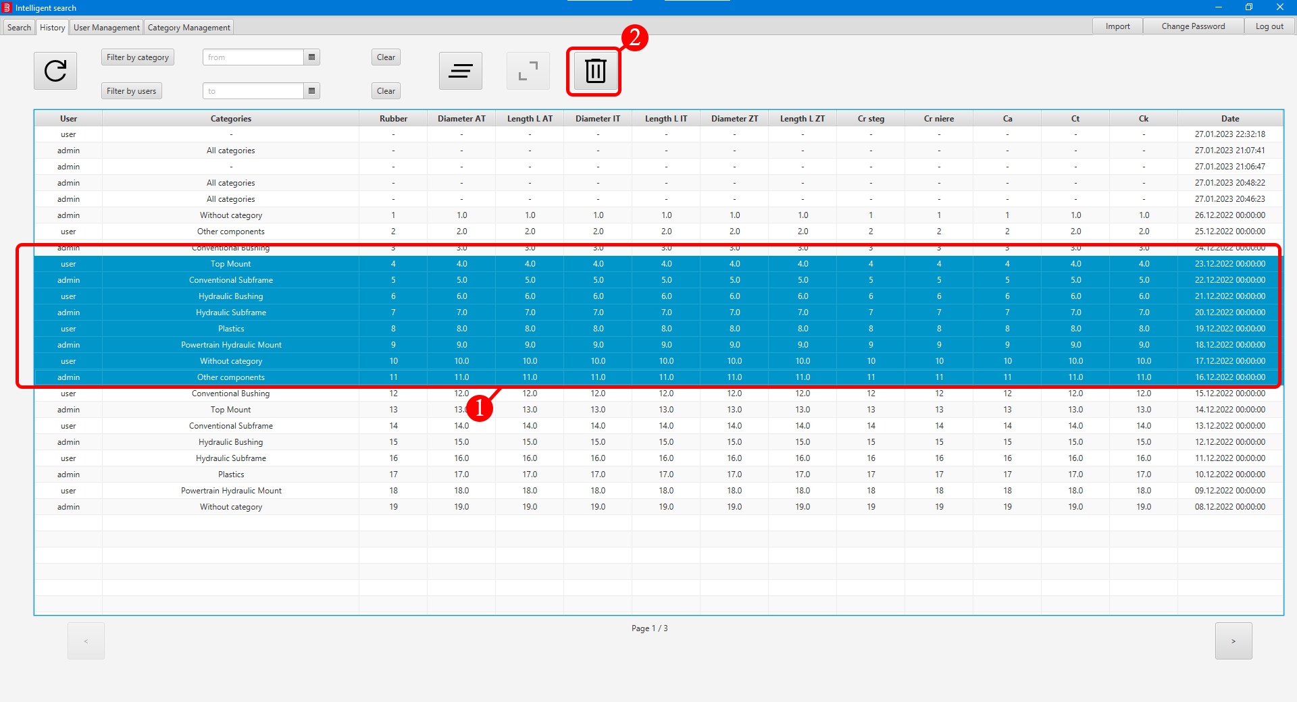

1. **Browse history**. Check **Browse history** chapter for more details.
2. Row **selection**.
   1. To select only one row, left click on the row. Selected row will be highlighted.
   2. To select multiple rows from start to end, left click on any row to select the start, then while holding the left Shift key left click on the end row. Selected row(s) will be highlighted.
   3. To select multiple rows, while holding the left Shift key left click on any other row you wish to add to your selection. Selected row(s) will be highlighted.
3. Click on the **Bin icon**, new window will open.
4. Click the **confirm** button to **confirm** **the** **deletion**. Selected row(s) will be **permanently deleted**.

## Exporting

1. Exporting is associated with **History detail**. Check **History detail** chapter for more details.

# User management

## Add user

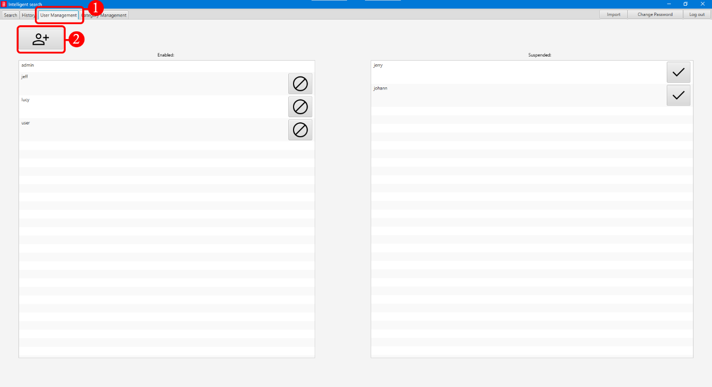

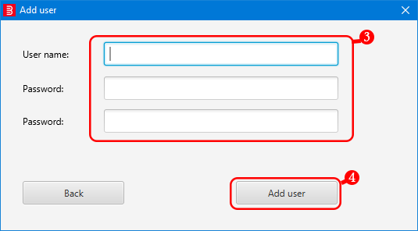

1. Click on the **User management** tab.

2. Click on **add user icon**, new window will open.

3. Type in **new username** and **2x new user password**.

4. Click on **Add user** button. In case of an error, a text message will be shown. Otherwise, the window will close and you will see the **new user** in the user list.

## Suspend/Enable user

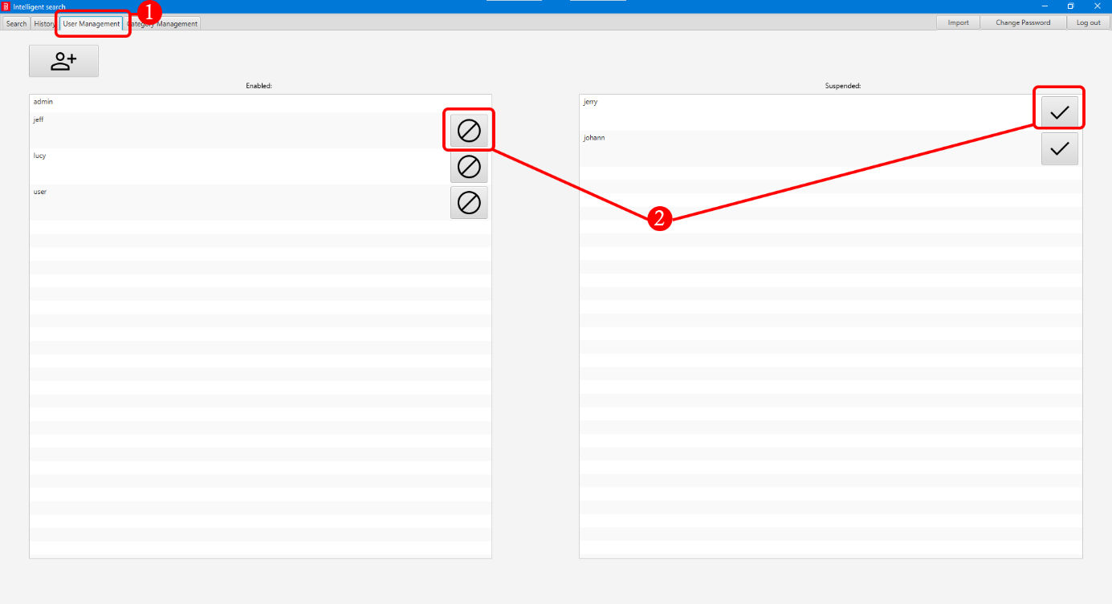

1. Click on the **User management** tab.

2. Click on **disable user icon** or **enable user icon**.

# Category management

## Add category

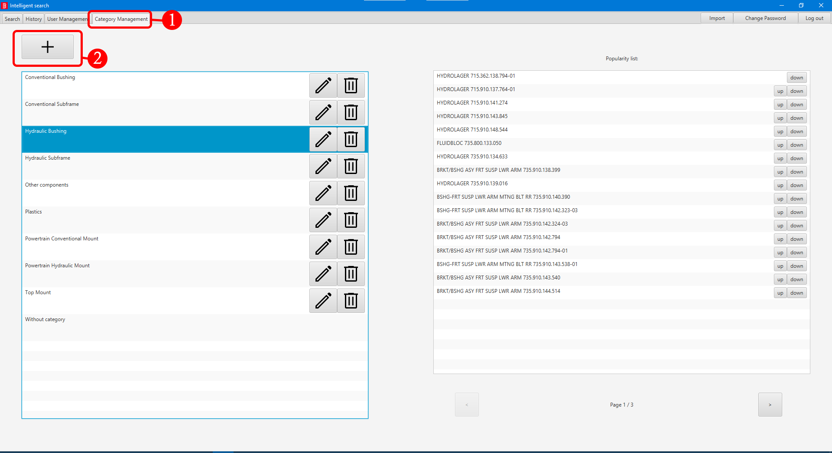

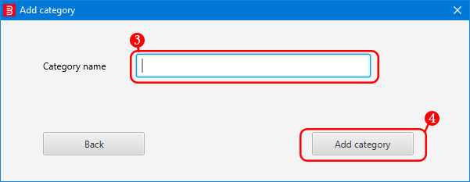

1. Click on the **Category Management** tab.
2. Click on **+** button, new window will open.
3. Type in **new category name**.
4. Click on **Add category** button. In case of an error, a text with error message will be shown. Otherwise, the window will close and new category will be added.

**Note:** in case of incorrect name you can rename this category. For more details check the **Rename category** section.

## Rename category

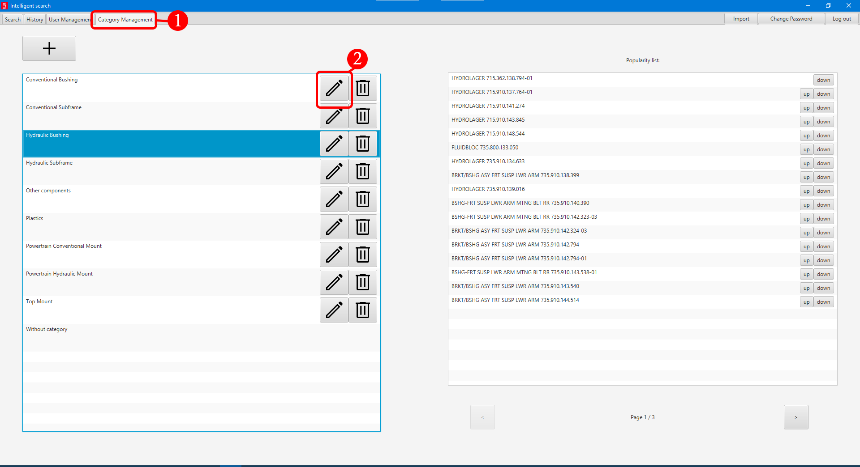

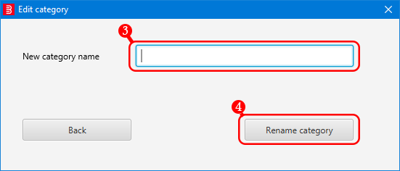

1. Click on the **Category Management** tab.
2. Click on the **pen icon** to edit the category name, new window will open.
3. Type in **new** **category name**.
4. Click on **Rename category**. In case of an error, a text with error message will be shown. Otherwise, the window will close and category will be renamed.

## Delete category

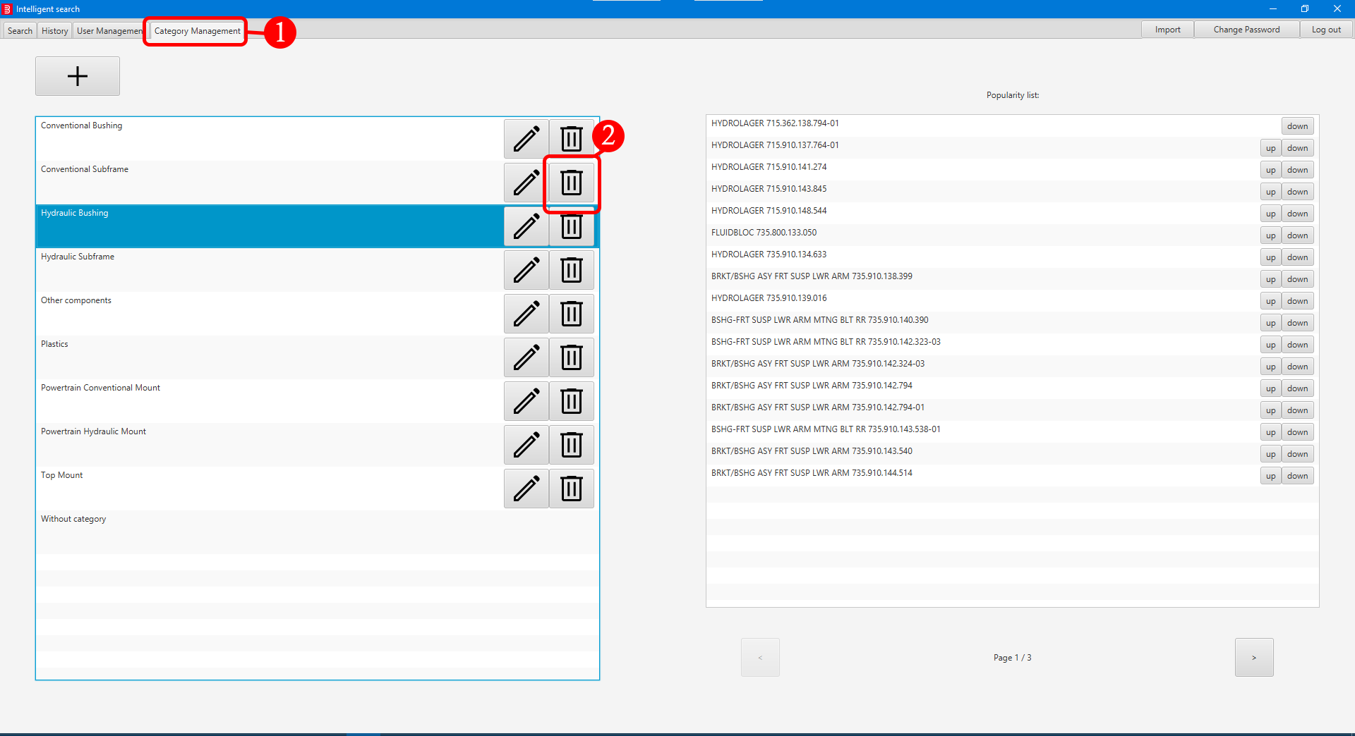

1. Click on the **Category Management** tab.
2. Click on the **trash bin icon** to remove the category.
3. New window will open and you will be prompted to confirm your action. Click on **Delete category** to delete the category. Any parts that had this category will still **remain** but will be **without** **category**.

## Change popularity of part

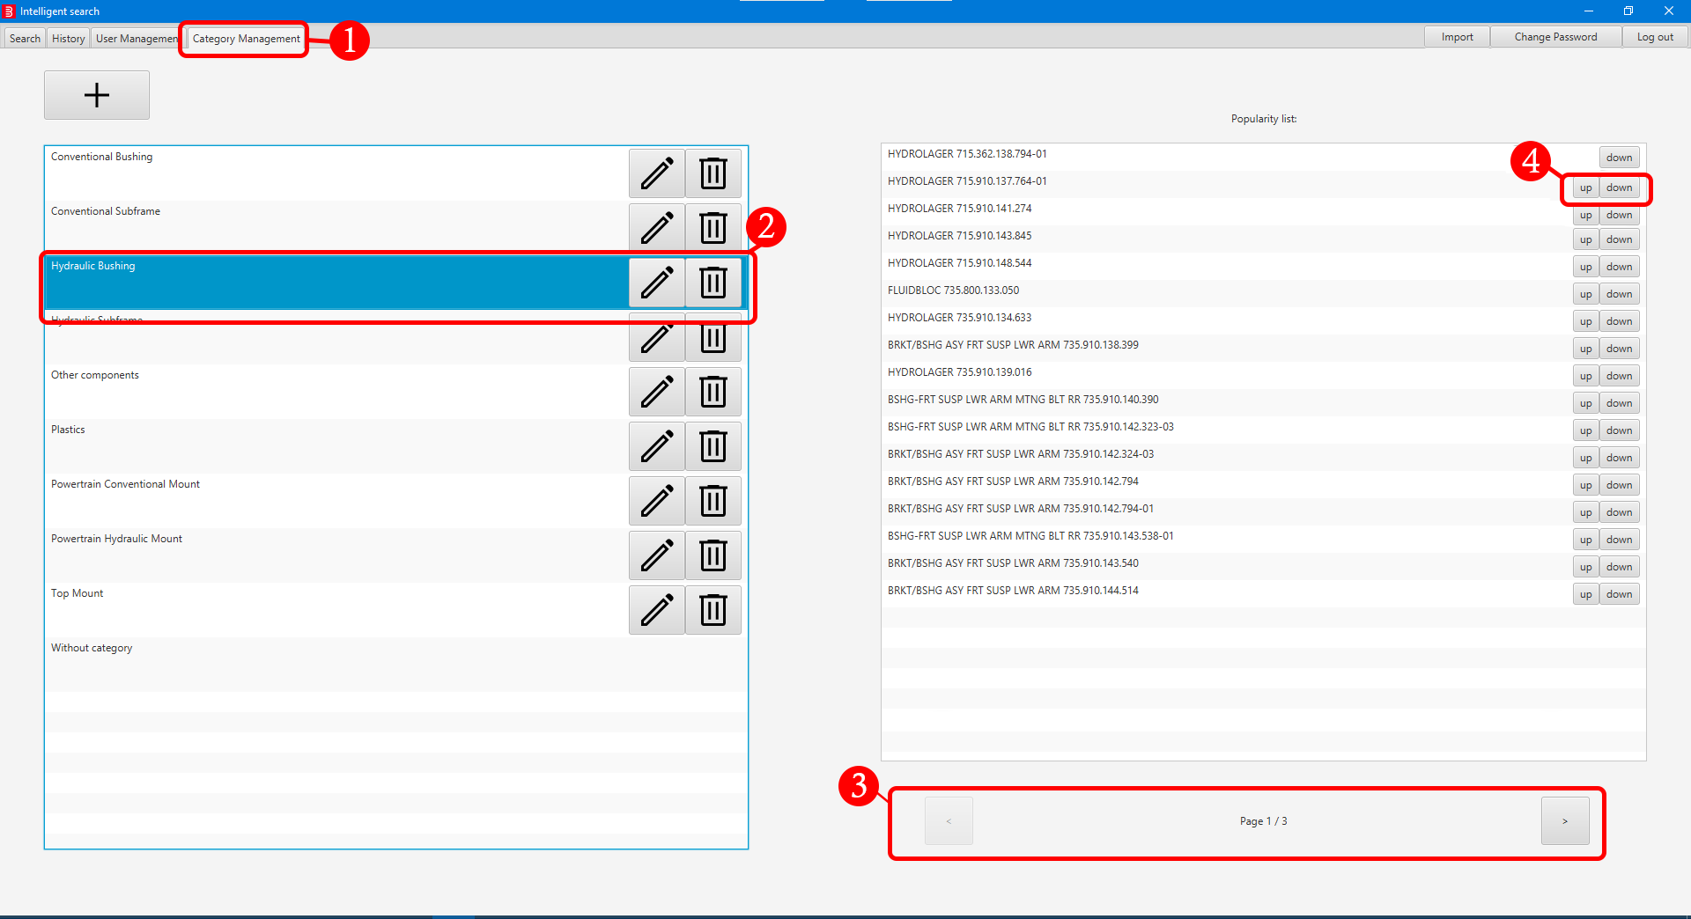

1. Click on the **Category Management** tab.
2. Select **category** you wish to change its **parts popularity**. Selected category will be **highlighted**.
3. Use **<** or **>** buttons to navigate through pages.
4. Click the **Up** or **Down** button to move **part** in the **popularity** **list**.

## Change part category

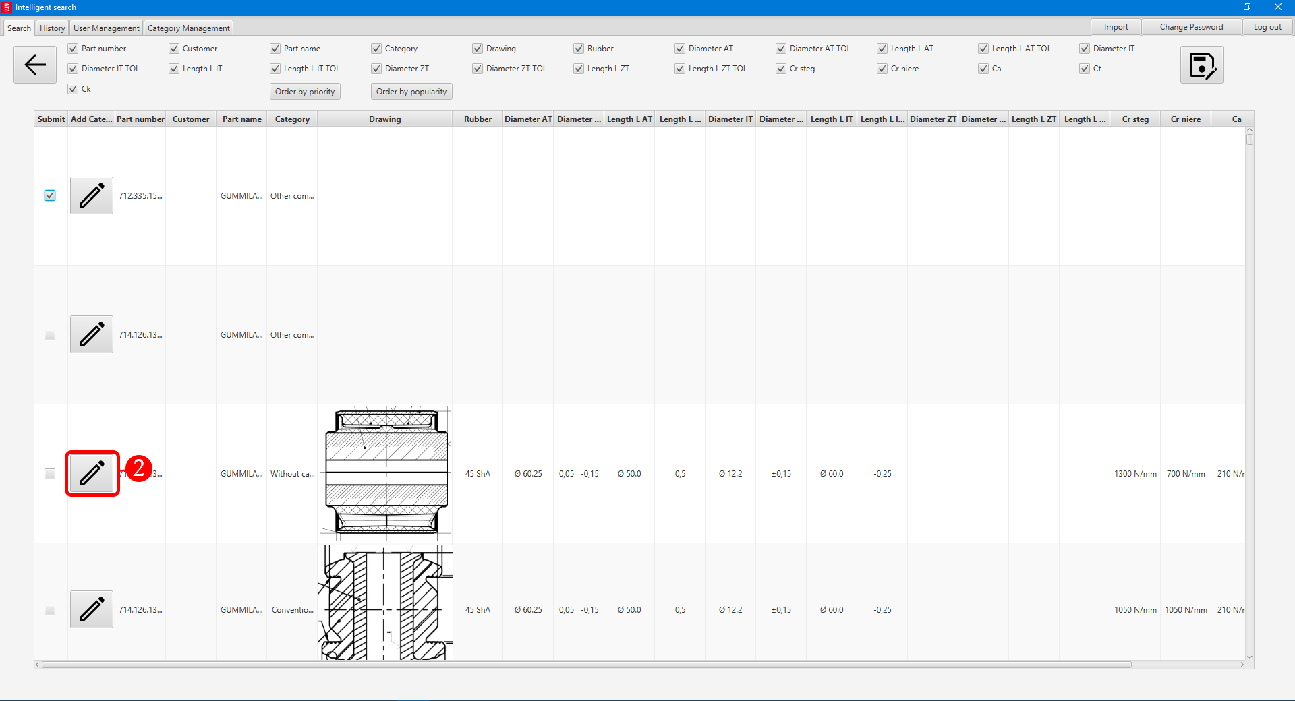



1. **Perform search**. Check **Performing search** chapter for more details.
2. Click on the **edit icon**, new window will open.
3. Select **new category** from the list and **confirm** your choice. The window will close and part category will be updated.

# Import

## Import

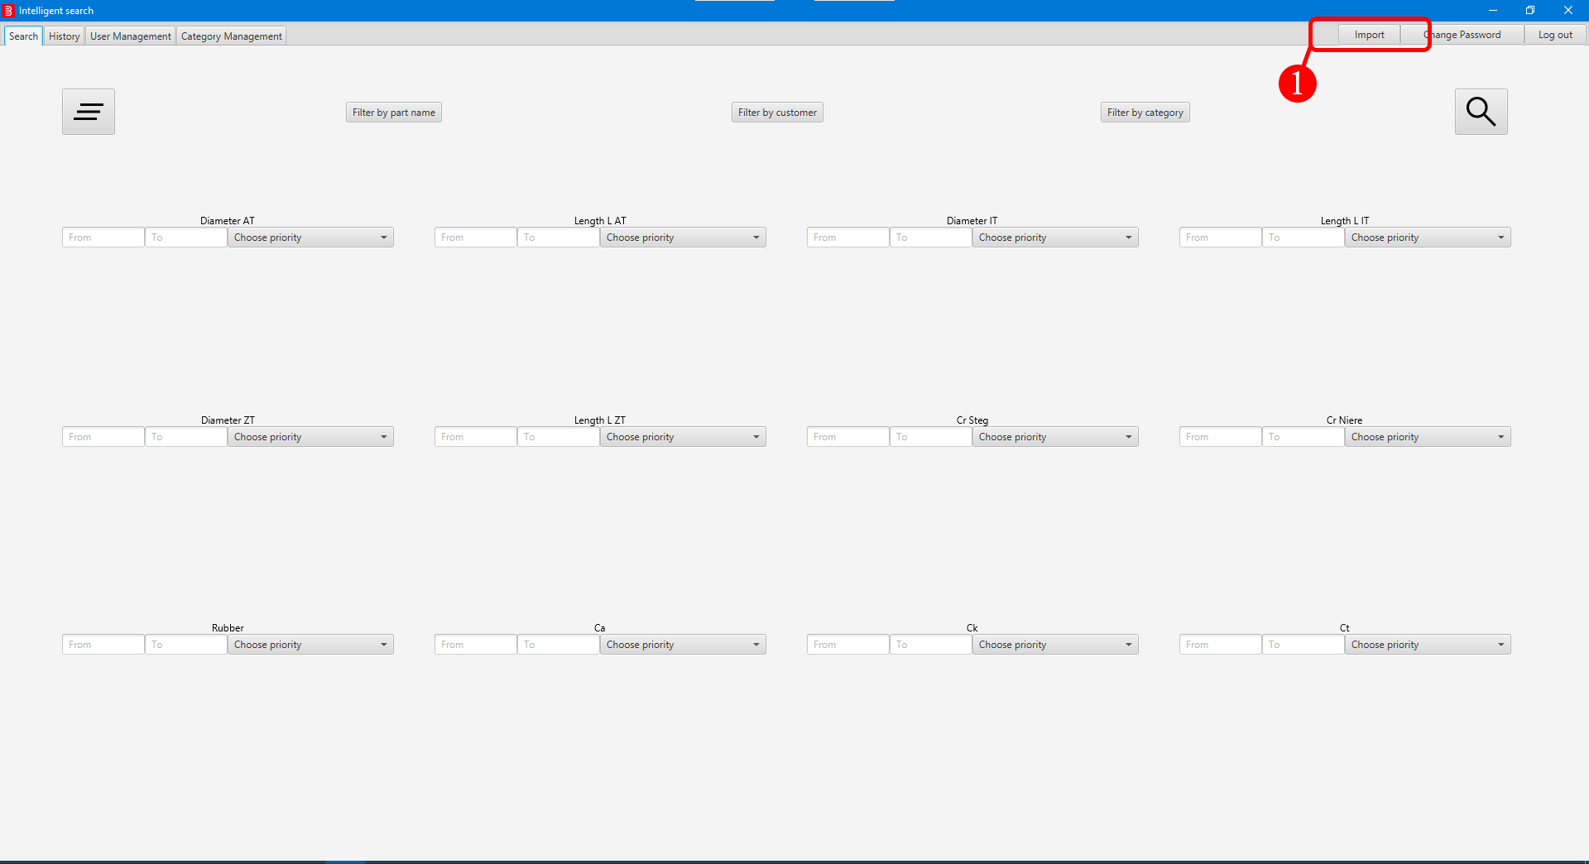

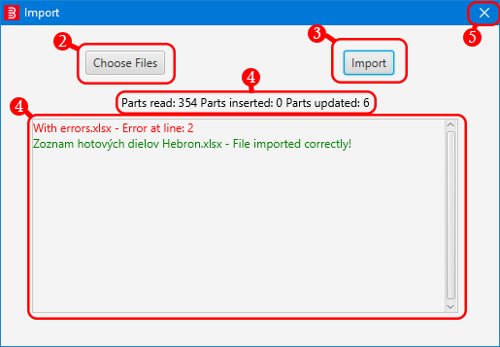

1. Click the **Import** button located at right top corner.
2. Click on **Choose Files** button and select file(s) to be imported. Selected file(s) will be displayed in the box below.
3. Click the **Import** button to start importing. While importing a text saying „Importing...“ will be shown.
4. After the **import process** finishes a text displaying how many parts were read/inserted/updated will be shown. Since article numbers are not unique, parts updated counter might not show 0 even if you did not perform any update in the imported file(s). **Correctly imported file(s)** will turn **green**, failed to import red. To learn how to deal with file(s) that failed to import check **Handling errors** section.
5. Close the window.

## Handling errors

1. Take a note of the file(s) that **failed** to import along with the **error message**. This message contains information where the error occurred during the import process.
2. Check the file(s) at line (row) displayed in the **error message**.
3. Check **software documentation** whether the file(s) you are trying to import are in **correct format**.